General Welfare Requirement: Safeguarding and Promoting Children's Welfare
The provider must take necessary steps to safeguard and promote the welfare of children

Gorran Pre School
Safeguarding children
1.5 Information sharing
"Practitioners need to understand their organisation's position and commitment to information sharing. They need to have confidence in the continued support of their organisation where they have used their professional judgement and shared information professionally."
Information Sharing: Guidance for Practitioners and Managers (DCSF 2008)
Policy statement
At Gorran Pre-School Hoglets we recognise that parents have a right to know that information they share will be regarded as confidential as well as be informed about the circumstances, and reasons, when we are obliged to share information.
We are obliged to share confidential information without authorisation from the person who provided it or to whom it relates if it is in the public interest. That is when:
- it is to prevent a crime from being committed or intervene where one may have been or to prevent ham to a child or adult; or not sharing it could be worse than the outcome of having shared it.
The decision should never be made as an individual, but with the back-up of management committee officers. The three critical criteria are:
- Where there is evidence that the child is suffering, or is at risk of suffering, significant harm. Where there is reasonable cause to believe that a child may be suffering or at risk of suffering significant harm.
- To prevent significant harm arising to children and young people or serious ham to adults, including the prevention, detection and prosecution of serious crime.
EYFS key themes and commitments
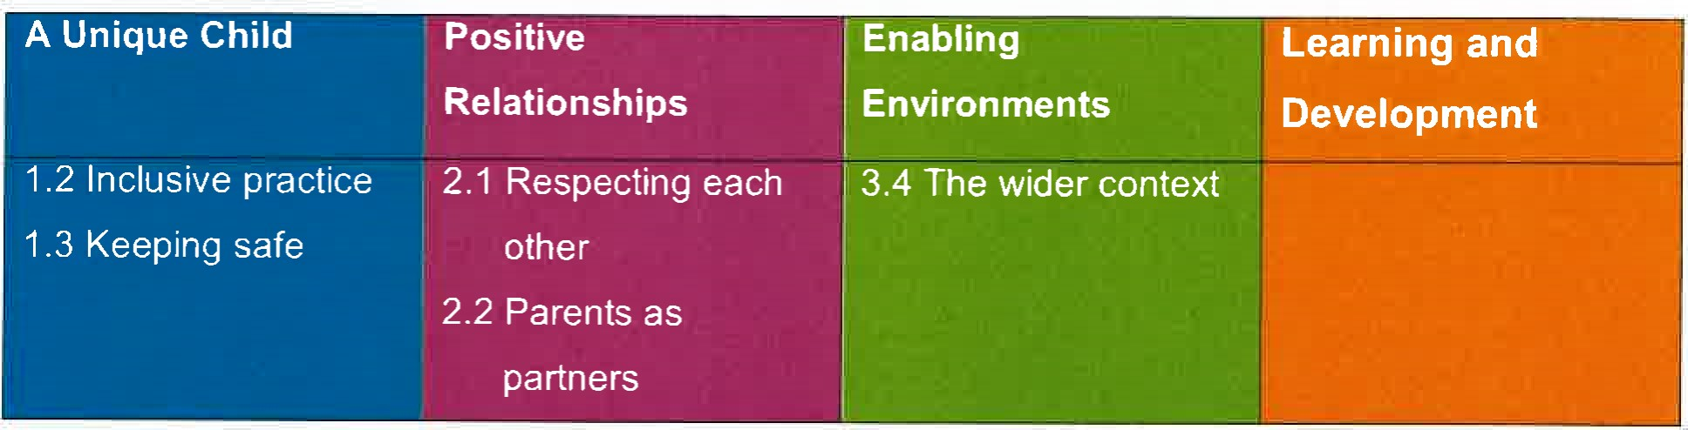

Procedures
Our procedure is based on the 7 golden rules for information sharing as set out in Information Sharing: Guidance for Practitioners and Managers (DCSF 2008).
- Remember that the Data Protection Act is not a barrier to sharing information but provides a framework to ensure that personal information about living persons is shared appropriately.
  - Our policy and procedures on information sharing provide guidance to appropriate sharing of information with external agencies.
- Be open and honest. Explain to families how, when and why information will be shared about them and with whom. Seek consent to share information, unless it puts the child at risk or undermines a criminal investigation
In our setting we ensure parents:
receive information about our information sharing policy when starting their child in the setting and they sign a form to say that they understand circumstances when information may be shared without their consent. This will only be when it is a matter of safeguarding a
child or vulnerable adult. This is on our registration form.
  - have information about our Safeguarding Children and Child Protection policy; and have information about the circumstances when information will be shared with external agencies for example with regard to any special needs the child may have or transition to school.
- Seek advice when there are doubts about possible significant harm to a child or others
Managers contact children's social care for advice where they have doubts or are unsure
- Share with consent where appropriate. Respect the wishes of children and parents not to consent to share confidential information. However, in the interests of the child, know when it is reasonable to override their wish.
Guidelines for consent are part of this procedure.
- Managers are conversant with this and are able to advise staff accordingly. Consider the safety and welfare of the child when making a decision about sharing information — if there are concerns regarding 'significant harm' the child's well being and safety is paramount.
In our setting we:
record concerns and discuss these with the setting's designated person and/or designated officer from the management committee for child protection matters. Record decisions made and the reasons why information will be shared and to whom; and follow the procedures for reporting concerns and record keeping.
- Information shared should be accurate and up-to-date, necessary for the purpose it is being shared for and shared only with those who need to know and shared securely.
  - Our Child Protection procedure and Record Keeping procedure set out how and where information should be recorded and what information should be shared with another agency when making a referral.
- Reasons for decisions to share information, or not, are recorded.
  - Provision for this is set out in our Record Keeping procedure
Consent
Parents have a right to be informed that their consent to share information will be sought in most cases, as well as the kinds of circumstances when their consent may not be sought, or their refusal to give consent overridden. We do this as follows:
Our policies and procedures set out our responsibility regarding gaining consent to share information and when it may not be sought or overridden.
We may cover this verbally when the child starts or include this in our prospectus.
  - Parents sign a form at registration to say they understand this.
  - Parents are asked to give written consent to share information about any additional needs their child may have, or to pass on child development summaries, to the next provider/school.
  - Copies are given to parents of the forms they sign.
We consider the following questions when we need to share:
  - Is there legitimate purpose to sharing the information?
  - Does the information enable the person to be identified?
Is the information confidential?
  - If the information is confidential, do you have consent to share?
Is there a statutory duty or court order to share information?
If consent is refused, or there are good reasons not to seek consent, is there sufficient public interest to share information?
If the decision is to share, are you sharing the right information in the right way?
  - Have you properly recorded your decision?
All the undertakings above are subject to the paramount commitment of the setting, which is to the safety and well-being of the child. Please also see our Safeguarding Children and Child Protection policy.
Legal framework
Data Protection Act 1998
  - Human Rights Act 1998
Further guidance
  - Information Sharing: Guidance for Practitioners and Managers (DCSF 2008)

This policy was adopted at a meeting of
Held on: October 2019
Date to be reviewed: October 2020
Name of signatory

Gorran Preschool

Role of signatory (Manager)

